***Viruses and plant species identity alters behavior of predators and prey in an aphid-legume system***

**Abstract:**

Herbivorous insects significantly influence agricultural systems, as primary consumers and vectors of plant pathogens. Carnivorous insects and other secondary consumers act as a regulatory force by constraining the growth of herbivorous insect populations and the spread of plant pathogens. Previous research has revealed the impacts of host-plant characteristics on predator-prey interactions, illustrating the importance of interspecific variation. However, further research on the influence of increased interspecific variation is needed to better understand biological interactions in agricultural systems. We conducted an experiment in which we varied host-plant species and viral status to determine the influence of these traits on predator-prey interactions between ladybird beetles and pea aphids. Our greenhouse experiment consisted of monitoring both foraging behavior and aphid predation events by ladybird beetles, and aphid behavioral response to ladybird beetles. This experiment was conducted using 3 different legumes (pea, vetch, and lentil) under two treatment types (infected and uninfected). We discovered that ladybird beetle foraging effort varied by plant species, and that virus presence reduce predation event abundance. Aphid fleeing behavior varied by the interaction of plant species and viral status, dramatically altering dispersal of aphids on some species and not others. Our experiments reveal that increased interspecific variation in the form of viral status alter the biological interactions between ladybird beetles and pea aphid. Thus, we suggest that in ecosystems where herbivorous insects serve as biological vectors for plant pathogens, viral status must be considered to better understand predator-prey interactions.

**Intro:**

*Big Picture Significance:* aphid-vectored viruses change aphid behavior, leading to different patterns of host-plant use and change in predation risk

*Basic Info:* Pea aphids are an economically important damaging pest of legume crops worldwide (citations). While feeding on plant phloem, aphids can transmit carried pathogens to plants (citations). One of the costliest impacts is transmission of pathogens, which can far outweigh the damage caused by herbivory itself (citations). Viruses can also alter plant defensive chemistry and nutritional quality, leading to indirect benefits to the vector, further exacerbating the intensity of aphid outbreaks (citations). Viruses are also increasingly appreciated for their ability to alter aphid behavior in addition to plant response to herbivores, the ecological consequences of these behavioral changes are still poorly understood.

*Hypotheses and predictions*: (Summarize outline below as best as possible):

Hypothesis 1: Predator behavior and prey response will be mediated by host plant species

* Figure 1 supports it
  + Virus might further reduce predator recruitment to pea (add in statistics later)
    - Proven in post hoc 🡪 follow up test for just that category
* Figure 2: plant species did not impact attack events
* Figure 3: Aphid dispersal in response to natural enemy vary between host plant species but this effect is contingent on infection status (interaction between both hypothesis)

Hypothesis 2: Predator behavior and prey response will be mediated by virus presence

* Figure 1 does not give support for this
  + Didn’t see any evidence that virus affects foraging effort
* Figure 2: virus significantly reduces the number of attack events
  + Interpretation: PEMV either makes it harder for ladybugs to find prey or aphids with PEMV are more likely to move and evade ladybugs
* Figure 3: Aphid dispersal in response to natural enemy vary between host plant species but this effect is contingent on infection status (interaction between both hypothesis)
  + Pea without virus has most dispersal
  + Pea with virus has least dispersal
  + Fig 2 🡪 presence of virus reduces overall number of attack events across all plant species 🡪 figure three to explain pea having the least dispersal events when virus present (pea x virus interaction)
  + *** What we are measuring is short term dispersal in response to predator presence/threat (emphasize in intro)
  + Did not see the same pattern in lentil
    - Virus did not influence dispersal mechanisms in lentil
  + Virus magnified the difference in dispersal between pea and vetch
    - Vetch had significantly more dispersal when virus was present
  + Vetch and Pea
    - Normally (PEMV absent) aphid response to predators is consistent between pea and vetch
    - But when adding virus to the system you see significantly more dispersal away from vetch in the presence of natural predators
      * This could explain why we saw increased movement from pea aphids away from vetch in Thunderdorm experiment (reference)
* Don’t have a way to tell the differences between aphid behavior due to PEMV presence and differences in predator-prey interaction due to plant differences

**Methods:**

*Study System:*

Pea aphids (*Acryothosiphon pisum*) are ubiquitous herbivores of legumes found abundantly Palouse agroecosystems in Eastern Washington and Idaho, USA (citiations outlined in Clark et al. 2019). Pea aphids are obligate vectors of Pea enation mosaic virus (PEMV). PEMV is a persistently transmitted pair of RNA virus which infects cultivated legumes and cover crops, including lentil, vetch, clover, and dry pea (citations from Clark et al. 2019). Pea aphids are susceptible to predation by convergent ladybeetle (*Hippodamia convergens*), and thus utilized as our focal predator species. (again, add citations from Clark et al. 2019).

*Experimental design:*

To test our hypothesis that host-plant identity and infection status impact predator-prey behavior, we ran a series of behavioral experiments among multiple host plant species and PEMV+/PEMV- Pea aphids. Host plant species included lentil (latin name here), fava (latin), pea (latin), and common vetch (latin). Seeds for all host-plant species were sown on January 11 into 3.5cm2 pots. Plants were inoculated after 21 days using 50 mixed-age viruliferous aphids. In all, we used 36 pea, 120 fava, 30 lentil, and 36 vetch across the 2 trials (all these numbers should just be what we included in analysis from raw data. There is no need to tell how many we actually planted if they were not used in the assay).

*Behavioral observation:*

The trials were conducted across three-day period. We ran a two by three factorial experiment, consisting of three different host plant species, half of which were infected with PEMV and the other half were not. 25L glass terrariums were prepared with the tops covered with wire mesh with a whole cut in the middle to allow for ease of positioning plants without loss of ladybird beetles. In each terrarium, four aphid-free host plants (pea, lentil, or vetch) were arranged in a cross on each side of the terrarium, for a total of 8 host plants per terrarium (See Figure S1). A final host plant with aphids present was selected, and the numbers of adult and nymph aphids were recorded before the plant was placed in the center of the cross of host plants arranged on each side of the terrarium. Each tank contained five host plants, 8 of which had no aphids, and the 2 center plants contained aphids. 25 adult ladybird beetles were then added to the terrarium, and a lid was placed over the top to prevent escape. We quantified aphid position and predator behavior at one-minute intervals for thirty minutes: this included number of ladybird beetles present on the center host plant indicating foraging behavior, how many attack events occurred on aphids, and if there were aphid fleeing events such as moving to a different host. At the end of the thirty minutes, the center host plants were removed, and the numbers of remaining adult and nymph aphids were counted. Once plants were used in a terrarium experiment trial, they were not used again. However, the same groups of ladybird beetles were used across the same day of testing.

*Statistical Analyses:*

We ran three generalized linear models (GLMs) using R ver. 3.5.2 (R Working Group, 2018). In the all models GLM, host-plant species, infection status of aphids, and their statistical interaction term were used as predictors. Ladybird beetle foraging time on plants, total number of predation events, and aphid dispersal events were used as responses in each of the three models, respectively.

All behavioral observations involved multiple observers (at least three observers) and tested for observation bias.

**Results:**

Use results written under each panel in the SURCA poster, I will add significance values later.

Fig. 1. Schematic diagram showing two interaction modifications: Virus instigated changes to predator-prey interactions (curved, dashed line), and changes to predator-prey interactions due to host-plant species (curved, solid line).

Fig. 2. Ladybird beetle foraging time on each host-plant species. Dots indicate predicted marginal means and whiskers the standard error of the mean.

Fig. 3. Total number of ladybird attacks based on infection status of aphids. Dots indicate predicted marginal means and whiskers the standard error of the man.

Fig. 4. Cumulative number of dispersal events based on host-plant species x infection status. Dots indicate predicted marginal means and whiskers the standard error of the man.

**Discussion:**

Our results indicated that there was a relationship between both hos plant species and viral status on the predator-prey interaction between ladybird beetles and pea aphids. Knowing this, these interactions become more important to the containment of herbivore vectored pathogens within agricultural ecosystems. Viral presence reduced the number of ladybird beetle attack events, perhaps by making it harder for ladybird beetles to find aphids, or by increasing evasive behaviors in aphids infected with PEMV. When considering the agricultural losses due to PEMV, knowledge of the mechanisms of how PEMV presence reduce attack events by ladybird beetles becomes of vital importance. However, we are unable to differentiate between aphid behavioral modifications due to PEMV presence and differences due to host plant species differences. Further research is needed to differentiate between the two.

**Acknowledgements:**

Thank to Logan Hope and Logan Dean for their assistance in experimental set up and completion, and Benjamin Lee for maintaining ladybird beetle and aphid colonies. This work was supported by USDA Grant (listed in Clark et al. 2019). Dana Roach was supported by Washington State University’s College of Agricultural, Human, and Natural Resource Sciences “Wild legumes of the Palouse: Insect food web interactions in natural and agricultural ecosystems” Internship.

**References:**

**Figures:**

Fig. 1

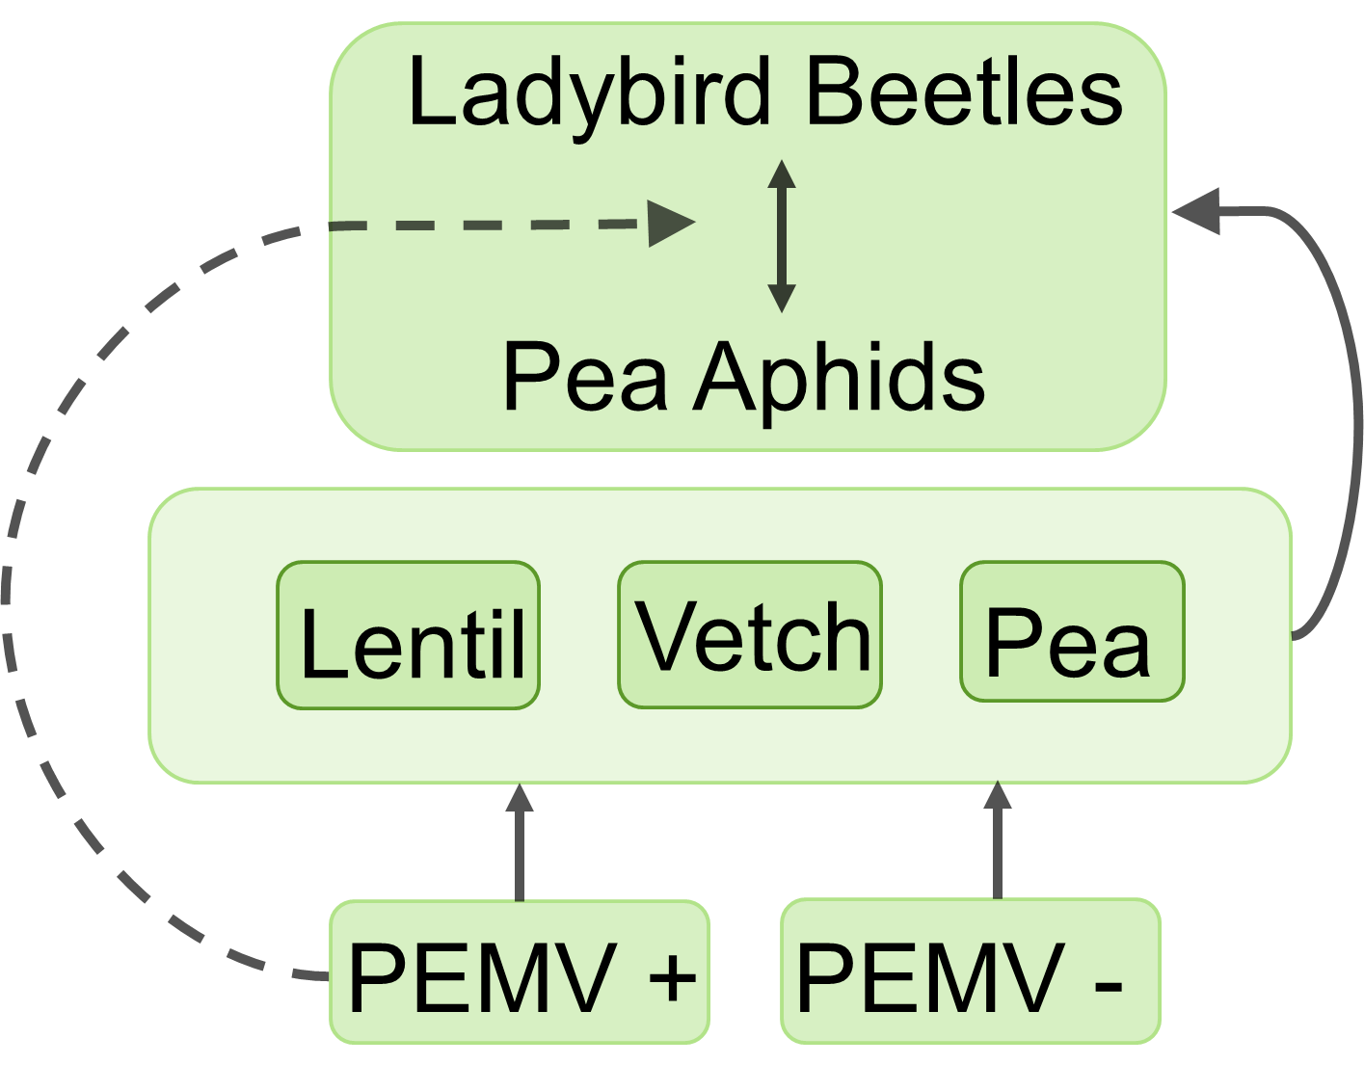

Fig 2.

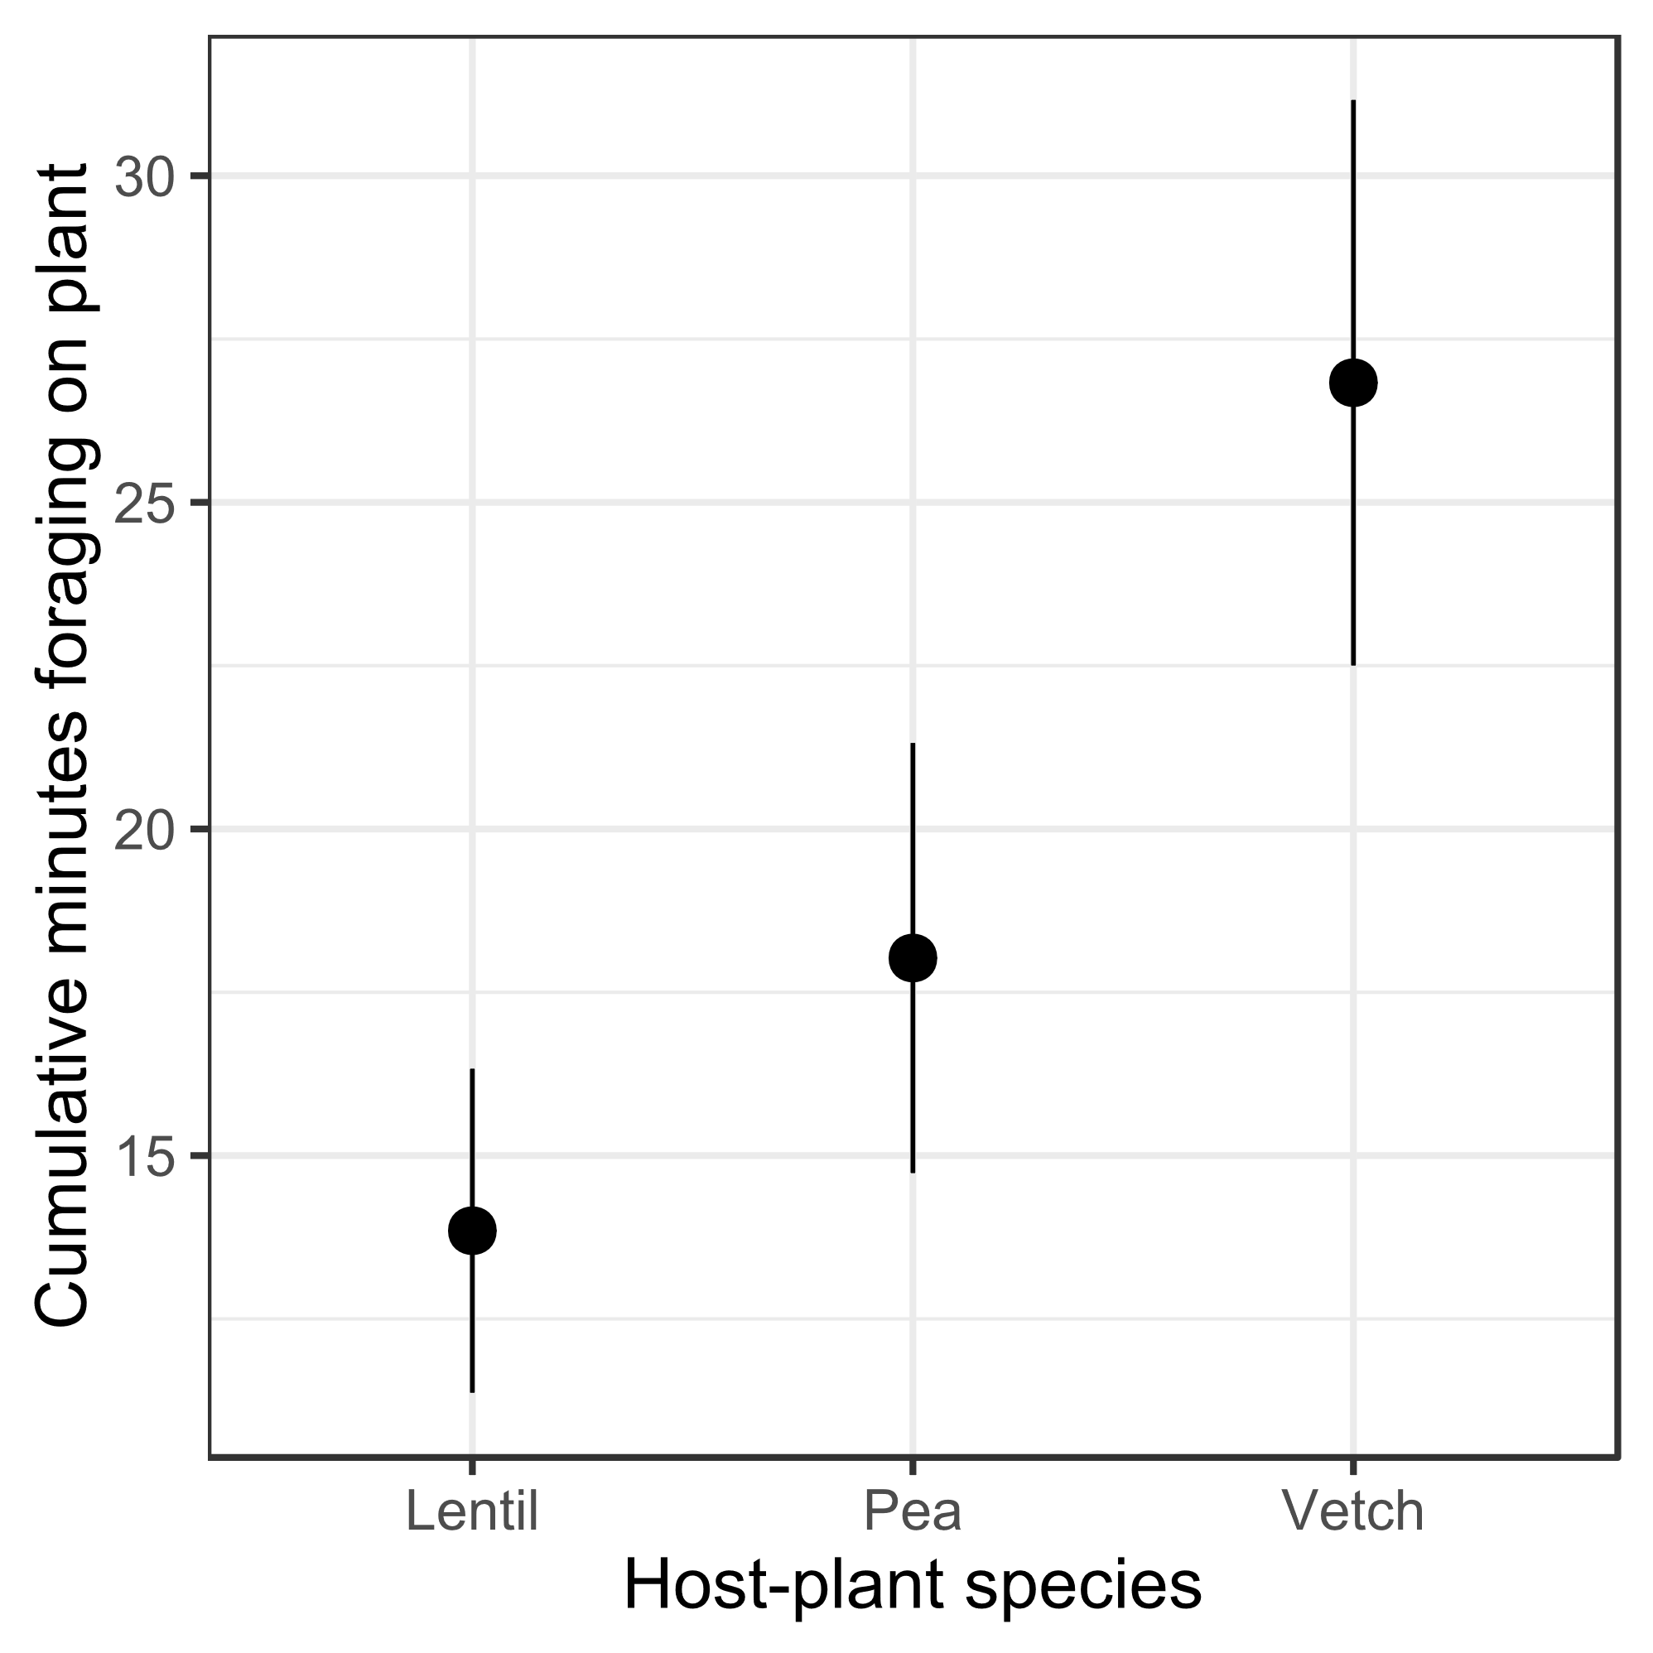

Fig. 3

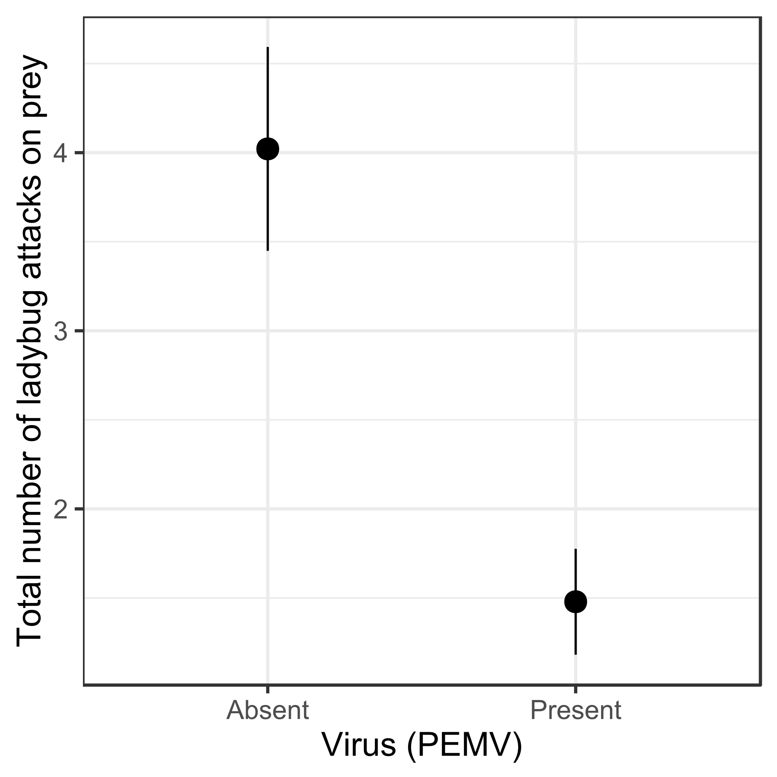

Fig 4.

